assignment-2

import random

while(True):

temp=random.randint(10,99)

humid=random.randint(10,99)

print("current temperature:",temp)

print("current humidity:",humid,"%")

temp_ref=37

humid_ref=35

if temp>temp_ref and humid<humid_ref:

print("alarm on")

else:

print("alarm off")

break

output:

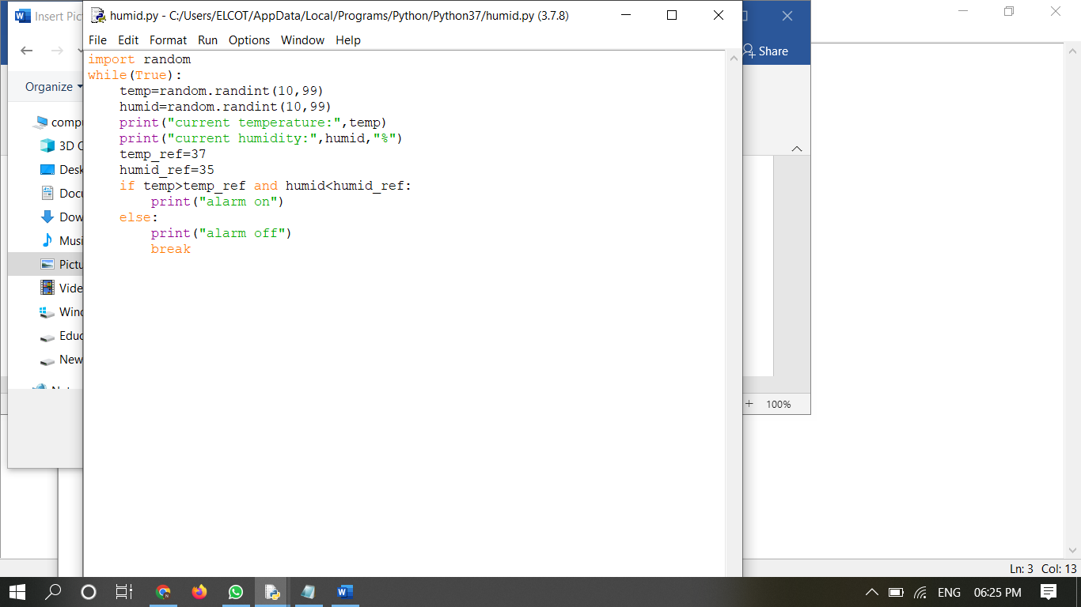

Program output:

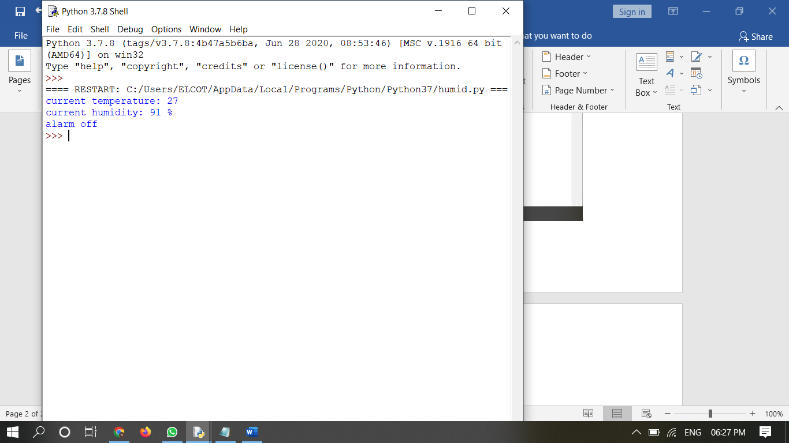

current temperature: 27

current humidity: 91 %

alarm off